A

Project Report

on

**SMART ATTENDANCE SYSTEM USING QR CODE**

Submitted to

**CHHATTISGARH SWAMI VIVEKANAND**

**TECHNICAL UNIVERSITY BHILAI**

*in partial fulfillment*

*for the award of the degree*

*of*

**Bachelor of Engineering**

in

**Computer Science and Engineering**

by

Rohit Kushwaha, 300102220127 Kunal Kanwar, 300102220045

Harsh Netam ,300102220032 Shubham Debnath ,300102220099

**Under the Guidance of**

**Prof. Dinesh Kumar Bhawnani Prof. Kauleshwar Prasad**

**Assistant Professor Assistant Professor**



**Department of Computer Science and Engineering**

**Bhilai Institute of Technology,**

**Bhilai House, GE Road, Durg, Chhattisgarh 491001**

**Session: 2021 – 2022**

**DECLARATION BY THE CANDIDATE(s)**

I/we the undersigned solemnly declare that the report of the project work entitled *SMART ATTENDANCE SYSTEM USING QR CODE* is based on my work carried out during my study under the supervision of **Prof. Dinesh Kumar Bhawnani and Prof. Kauleshwar Prasad.**

I assert that the statements made and conclusions drawn are an outcome of the project work. I further declare that to the best of my knowledge and belief that the report does not contain any part of any work which has been submitted for the award of any other degree/diploma/certificate in this University/ any other University of India or any other country.

**_________________**

(Signature of Student)

Rohit Kushwaha

Roll No.: 64

Enrollment No.:BK2553

**CERTIFICATE**

This is to Certify that the report of the project submitted is an outcome of the project work entitled SMART ATTENDANCE SYSTEM USING QR CODE carried out by **Rohit Kushwaha bearing Roll No 64, Enrollment No: BK2553; Kunal Kanwar bearing Roll no. 27, Enrollment No: BK4119 Shubham Debnath bearing Roll No 51, Enrollment No: BK4279; Harsh Netam bearing Roll No 17, Enrollment No: BK4098**

Under my guidance and supervision for the award of Degree in Bachelor of Engineering in Computer Science from Chhattisgarh Swami Vivekanand Technical University, Bhilai (C.G).

To the best of my knowledge the report

1. Embodies the work of the candidate himself/herself,
2. Has duly been completed,
3. Fulfills the requirement of the Ordinance relating to the BE degree of the University,
4. Is up to the desired standard for which is submitted.

**Signature of Coordinator Signature of Coordinator**

**Prof. Dinesh Kumar Bhawnani Prof. Kauleshwar Prasad**

**Assistant Professor Assistant Professor**

**Computer Sc. & Engg Computer Sc. & Engg.**

The Project work as mentioned above is hereby being recommended and forwarded for examination and evaluation.

**Dr. (Mrs.) Sunita Soni**

**Head of the Department**

**Computer Sci. & Engg**

**CERTIFICATE BY THE EXAMINERS**

This is to Certify that the project the entitled

“**SMART ATTENDANCE SYSTEM USING QR CODE”**

Submitted by

**Rohit Kushwaha Enrollment No: BK2553 Roll No: 64**

**Kunal Kanwar Enrollment No: BK4119 Roll No: 51**

**Shubham Debnath Enrollment No: BK4279 Roll No: 27**

**Harsh Netam Enrollment No: BK4098 Roll No: 17**

Have been examined by the undersigned as a part of the examination for the award of Bachelor of Engineering degree in Computer Science and Engineering from Chhattisgarh Swami Vivekanand Technical University, Bhilai (C.G)

**(Internal Examiner) (External Examiner) Name: Name:**

**Date: Date:**

**ACKNOWLEDGEMENT**

I have great pleasure in the submission of this project report entitled **SMART ATTENDANCE SYSTEM USING QR** in partial fulfillment the degree of Bachelor of Engineering (CSE). While submitting this Project Report, I take this opportunity to thank those directly or indirectly related to project work.

I would like to express sincere thanks and gratitude to **Dr. Mohan Kumar Gupta,** **Principal of the Institution**, **Dr. (Mrs.) Sunita Soni,** **Head of the Department** Computer Science & Engineering for their encouragement and cordial support.

While Submission of the project, I also like to thanks to **Prof. Dinesh Kumar Bhawnani and Prof. Kauleshwar Prasad,** **Project Coordinator,** facultyand all the staff of department of Computer Science & Engineering, **Bhilai Institute of Technology, Durg** for their continuous help and guidance throughout the course of project.

Acknowledgement is due to our parents, family members, friends and all those persons who have helped us directly or indirectly in the successful completion of the project work.

**Name of the Student: Rohit Kushwaha Name of the students: Kunal Kanwar**

**Roll No:** 300102220127 **Roll No** : 300102220045

**Enrollment No:BK2553 Enrollment No:BK4119**

**Name of the students: Harsh Netam Name of the students: Shubham Debnaath**

**Roll No** : 300102220032  **Roll No** : 300102220099

**Enrollment No:BK4098 Enrollment No:BK4297**

ABSTRACT

Recording attendance is something repetitive and time-consuming. The process of attendance taking is the same and repeat every day. However, the attendance system today is not automated. It requires a lot of manual workforces to accomplish it. An automated attendance system can save human labor, and increase the efficiency of attendance taking. This will directly help lecturers to save time and spend more time on academic, rather than attendance records. This project intended to automate the attendance recording. The adopted development methodology is evolutionary prototyping to cater to constant user feedback and improvements. The project had conducted testing on 2 classes, one lecture class, and one practical class. The results were accurate and eliminated the need of signing attendance on attendance sheets, the manual efforts to transfer data on attendance sheets to the computer system. Some improvements have to be made before it is fully functional, for instance, the camera is not zoomable at the moment. This caused inconvenience to students who sit behind or with poor smartphone camera quality. In conclusion, the project had achieved the objectives, which ultimately save lecturers’ time in managing attendance, bring convenience to students on attendance registration, and reduce the likelihood of fake attendance records.

**INTRODUCTION**

**1. INTRODUCTION**

It is a well-known fact that virtually all organizations whether educational or commercial need to properly record the attendance of its students or employees for effective planning, management and functioning of the organization. In most universities in the developing countries, student’s attendance is usually taken by old file system approach by calling students name and using paper sheets, this approach is being used for a long time . It becomes difficult for the administration at the universities to regularly update the attendance record and manually calculate the percentage of classes absented and attended for the purpose of subsequent results processing and examinations. Keeping these issues in mind, this work designed and implemented a system to overcome the problems associated with attendance recording.

This chapter discusses the background, objective, and project description.

**1.1 OBJECTIVE**

The popularity of smartphones has increased over the year. This could change and speed up the attendance-taking process in universities. The current attendance system is time-consuming and required a manual workload. Lecturers will let the students sign on the attendance list. Then, he or she will key into the university’s portal to record the attendance, each for every class. This will consume lecturers’ valuable time. Also, it will introduce human errors during the transferring from paper attendance to digitalized attendance records. Besides, students can easily cheat on attendance by asking flavors from their friends, to sign on the attendance sheet on their behalf. This is hard to avoid when the attendance sheets were given to students. The proposed solution is based on a QR code to record students' attendance. The system will be able to verify students' identities and prevent false registration. All of the attendance records will be recorded in the system and available to students and lecturers instantly. This will eventually reduce the human efforts on attendance registration.

“QR Code Based Attendance Management System” is a combination of two programs developed for taking and storing the attendance of the students on the daily basis in the college. Here the professor, who is handling the subjects, will be responsible to mark the attendance of the students. Each staff will be given program application that is used for taking attendance and generate the overall attendance status. An accurate report based on the student attendance is generated here. Report of the student’s attendance on weekly and monthly basis is generated as desired. The main objective of the automated attendance system is to computerize the traditional way of recording attendance and provide an efficient and automated method to track attendance in institutions.

**1.1.2 GOAL AND OBJECTIVE**

This section discusses goals and objectives.

**1.1.3OBJECTIVES**

a. To simplify the current attendance-taking process by automating the process using QR Code scanning.

b. Increase the transparency of attendance records by enabling students and lecturers to view attendance records anytime.

c. Reduce cheating on attendance by enforcing cheat detection.

d. Minimize paper usage by eliminating the need for attendance sheets.

e. Goal Reduce administrative and lecturers labor manually and minimize paper usage.

**1.2 PROJECT DESCRIPTION**

The process of taking students' attendance in higher education in time consuming and inefficient. The process becomes harder to manage when the class size is big. Prevention of cheating on attendance is even harder to control. After each class, lecturers have to record the attendance to the related web-based system according to the attendance sheets. The whole attendance-taking process is consuming the valuable time of lecturers. With all the problems mentioned above, universities are not 18 changing the way they record attendance. Referring to Appendix A, 85% of the universities still recording attendance by signing on attendance sheets.

Mobile cellular penetration in Malaysia has reached 131.8% while smartphone penetration stood at 70% in the third quarter of last year (The Star). With the widespread of smartphones among students in university, and the problem of wasting lecturers’ time in the attendance-taking process, proposes a solution that offers to simplify the attendance-taking process. The proposed solution proposes a QR code for students to scan with their smartphones. The attendance will be confirmed with the identity from the smartphone. This will save time and effort to record attendance at the same time, reduce unwanted paper usage. The proposed solution identifies unauthorized attendance registration using multi-factor authentication. The details of authentication factors will be explained in the following chapters.

**2. SYSTEM STUDY**

**2.1 PROPOSED SYSTEM**

The proposed solution is by taking attendance using QR Code. 37.5% of respondents think that the QR Code solution is the most cost-effective. The reason for using QR codes is because it provides a low initial cost for implementing the system. By using the tools that everyone student has, smartphone to take attendance.

The solution has 2 modules, generator module and attendance module. Generator module generates QR code by using a given background image. The QR code can be updated every time during attendance to prevent cheating. This can prevent students who are not in class and wanted to scanning the QR code. The mobile module enables students to scan QR codes to confirm their attendance. The request is then sent to the attendance module for verification. Once the attendance is verified, the backend service module will update the database on attendance records. The whole process of attendance taking should be less than 5 minutes, which is much faster compared with the traditional process.

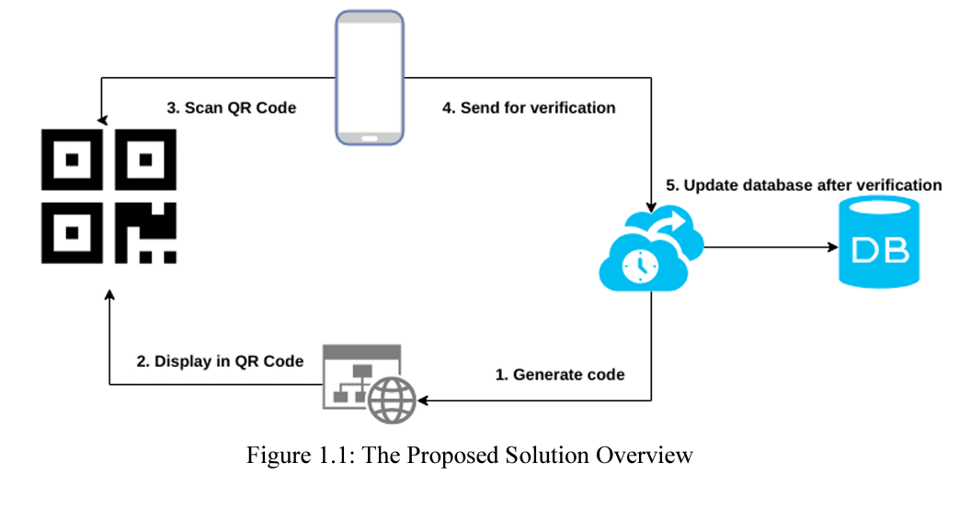

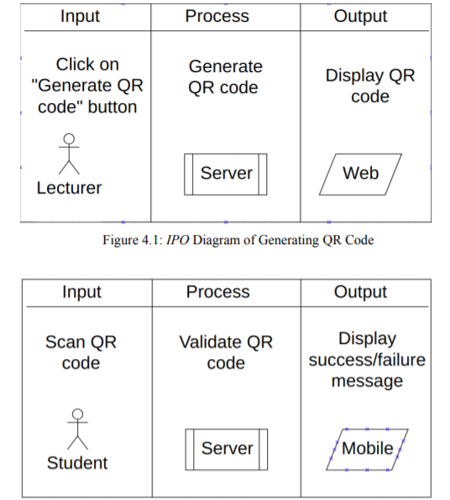

Figure 1.1: The Proposed Solution Overview

Students can view their attendance records for enrolled subjects, this can increase the transparency of the attendance system. The system also issues notifications if the attendance percentage is below than certain level. Moreover, lecturers also can manage students’ records with the web modules. Lecturers can update students’ attendance records in case they have valid reasons to be absent from class. Lecturers can manage the class as well. A new class can be created in case there is any class replacement. Existing classes can be modified or deleted by lecturers. Administrators can manage users with web modules. They can add new lecturers or students, update their details and delete existing users.

**2.2 FEASIBILITY STUDY**

**• Economic feasibility**: The developed system is time-effective because attendance is marked automatically. It is also cost-effective because of no use of paperwork. It saves money by putting an end to inaccurate time reporting, buddy punching, absenteeism, tardiness, time abuse, There will be no paperwork involved; all processes are performed by a computer. This will help protect against the loss of data.

**• Technical feasibility:** The system is economic and it does not use any other additional hardware and software. The computerized processes will be performed more quickly and accurately than the previous system.

**• Behavioral feasibility**: The system is user-friendly. Efficiently benefit from the complete assigned time assigned to a lecture. Time taken by instructors to take attendance may be viewed sometimes as a waste of lecture time, especially when classes are big. QR is the abbreviation of Quick Response. QR codes are like the linear bar codes we see on store products but more powerful as they can store large volume of data, can be scanned from paper and from a screen, can be read even if part of the code is damaged, and are more secure because the information they contain is encrypted.

**2.3 TOOLS AND TECHNOLOGIES USED**

**QR CODE**

A QR code (Quick Response code) is a type of matrix bar code (or two-dimensional barcode). A barcode is a machine-readable optical label that can contain information about the item to which it is attached. In practice, QR codes often contain data for a locator, identifier, or tracker that points to a website or application. A QR code uses four standardized encoding modes (numeric, alphanumeric, byte/binary, and kanji) to store data efficiently; extensions may also be used.

The Quick Response system became popular outside the automotive industry due to its fast readability and greater storage capacity compared to standard UPC barcodes. Applications include product tracking, item identification, time tracking, document management, and general marketing.

A QR code consists of black squares arranged in a square grid on a white background, which can be read by an imaging device such as a camera, and processed using Reed–Solomon error correction until the image can be appropriately interpreted. The required data is then extracted from patterns that are present in both horizontal and vertical components of the image.

QR codes are now used in a much broader context, including both commercial tracking applications and convenience-oriented applications aimed at mobile-phone users (termed mobile tagging). QR codes may be used to display text to the user, to open a webpage on the user's device, to add a vCard contact to the user's device, to open a Uniform Resource Identifier (URI), to connect to a wireless network, or to compose an email or text message. There are a great many QR code generators available as software or as online tools that are either free, or require a paid subscription The QR code has become one of the most-used types of two-dimensional code.

**PYTHON**

Python is an interpreted high-level general-purpose programming language. Its design philosophy emphasizes code readability with its use of significant indentation. Its language constructs as well as its object-oriented approach aim to help programmers write clear, logical code for small and large-scale projects.

Python is dynamically-typed and garbage-collected. It supports multiple programming paradigms, including structured (particularly, procedural), object-oriented and functional programming. It is often described as a "batteries included" language due to its comprehensive standard library.

Guido van Resume began working on Python in the late 1980s, as a successor to the ABC programming language, and first released it in 1991 as Python 0.9.0. Python 2.0 was released in 2000 and introduced new features, such as list comprehensions and a cycle-detecting garbage collection system (in addition to reference counting). Python 3.0 was released in 2008 and was a major revision of the language that is not completely backward-compatible. Python 2 was discontinued with version 2.7.18 in 2020.

Python is a multi-paradigm programming language. Object-oriented programming and structured programming are fully supported, and many of its features support functional programming and aspect-oriented programming (including by meta programming and meta objects (magic methods)). Many other paradigms are supported via extensions, including design by contractand logic programming.

Python uses dynamic typing and a combination of reference counting and a cycle-detecting garbage collector for memory management. It also features dynamic name resolution (late binding), which binds method and variable names during program execution.

**2.4 HARDWARE AND SOFTWARE REQUIREMENTS**

**Libraries used**

**1.MyQR library**

**2.OpenCV**

**3.NumPy**

**4.sys**

**5.pybase64**

**3.SOFTWARE REQUIREMENTS SPECIFICATION**

**3.1 Introduction**

This chapter discusses system flow, use case, and project requirements.

Use Case This section discusses use cases.

4.3.1 Use Case Diagram

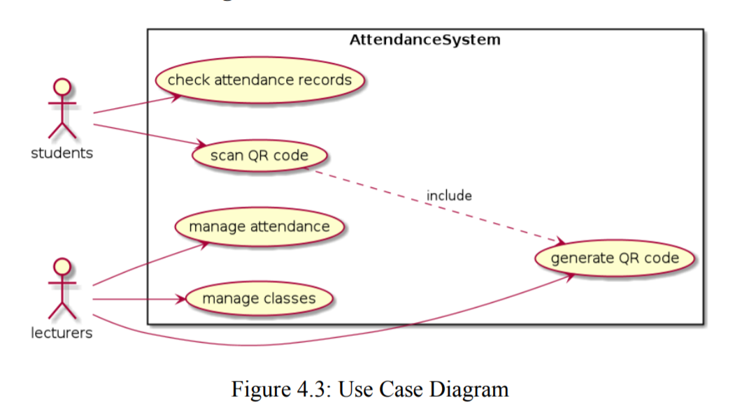

Software Requirements This section discusses functional and non-functional requirements.

**3.2** **Functional Requirements**

**Lecturers**

1. The system shall be able to generate QR codes
2. The system shall be able to manage attendance records

i. The system shall be able to view attendance records

ii. The system shall be able to update attendance records

iii. The system shall be able to view bar lists

3) The system shall be able to manage classes

i. The system shall be able to create classes

ii. The system shall be able to view classes

iii. The system shall be able to update classes

iv. The system shall be able to delete classes Students

**Students**

1. The system shall be able to scan QR codes to record attendance

2) The system shall be able to check attendance records

i. The system shall be able to check attendance records for all classes

ii. The system shall be able to view students’ attendance percentage

iii. The system shall be able to view class details with time and venue

**3.3 Non-Functional Requirements**

i. The system shall prevent cheating attendance by verifying the request.

ii. The system shall prevent unauthorized login on users' accounts.

iii. The system shall be error-tolerant. iv. The system shall be fast and responsive.

**4. SYSTEM ANALYSIS AND DESIGN**

**4.1 SYSTEM PERSPECTIVE**

We need to create a folder that will contain the required elements to generate a QR – code for each individual student. Also, the QR- Codes generated will also be stored in this folder.

The contents of this folder are:

* Background image: This will act as background for the image to be generated.
* Text file: This will contain the names of the students, for each student a unique QR-

Code will be generated.

**Input:**The background image will act as an input for the system which will use this image as a background for the QR- Code.

**Output:** Here the output from the system will be QR-Codes which will contain the names of the students.

Now for the next set of process of taking attendance and verifying it, this process will be handled by the attendance module. For this module:

**Input:** The input for this module is the camera of the system. The camera will take an image and this module will verify this image.

**Output**: This module will verify the QR-Code and tell the user whether the attendance is marked or the QR-Code is invalid. If that QR-Code is already verified or the attendance of the student is already taken it will show student name already present.

**4.2 CIRCUIT DIAGRAM / FLOW CHART OF ALGORITHM**

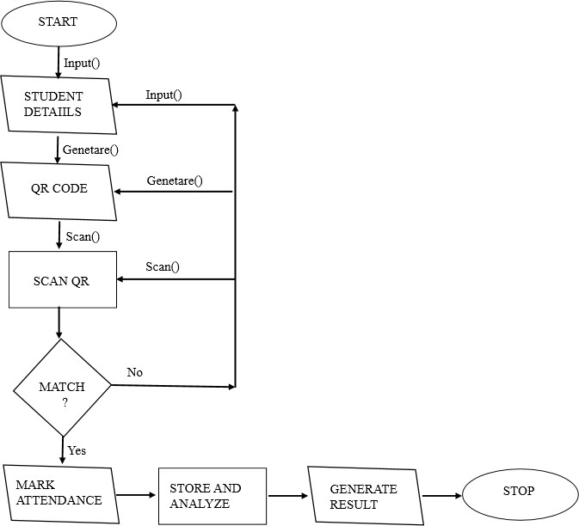

**5. IMPLEMENTATION**

**#CODE**

**(Generator Code)**

from MyQR import myqr

import os

#create a text file and fill the information line by line

#create and read the text file

f=open("C:\Users\kush\QRAttendance\Attendance QR\QR Generater\data.txt",'r')

lines = f.read().split("\n")

print (lines)

# using for loop for generating multiple qr codes

for i in range(0,len(lines)):

data=lines[i]

name=data

print(name)#data is used to encode lines

#following are requirements for using base64

version, level, qr_name = myqr.run(

str(name),

version = 1,

level = 'H',

#background for QR-code

#you can use any picture in the background including gif

picture = 'a.jpg', #select picture you want to use

colorized = True, #select if you want colour or not

contrast = 1.0,

brightness = 1.0,

save_name = str(lines[i]+'.bmp'), #concatenate name and the file type of qr , this is file name

save_dir = os.getcwd() #save this file in the directory we are using

)

**#CODE**

**(Attendance QR)**

import cv2

import numpy as np

import pyzbar.pyzbar as pyzbar

import sys #provides modules to access variables and functions

import time

import pybase64 #used for encoding the data

# starting the webcam using opencv

cap = cv2.VideoCapture(0)

fob=open('attendence.txt','a+') #creating a file to store attendence record

names=[] #names of the students

#function for writing the data into text file

def enterData(z):

if z in names:

pass

else:

names.append(z)

z=''.join(str(z))

print(z)

fob.write(z+'\n')

return names

print('Reading Code...')

#function for check the data is present or not

def checkData(data):

data=str(data)

if data in names:

print('Already Present')

else:

print('\n'+str(len(names)+1)+'\n'+'Present done')

enterData(data)

#command to read the camera frame

while True:

_, frame = cap.read()

decodedObjects = pyzbar.decode(frame) #decoding the frame and storing it

for obj in decodedObjects:

checkData(obj.data)

time.sleep(1) #used to add delay in program

cv2.imshow("Frame", frame)

#closing the program when s is pressed

if cv2.waitKey(1)& 0xFF == ord('s'):

cv2.destroyAllWindows()

break

fob.close()

**Conclusion**

In conclusion, taking attendance with QR codes is the cheapest and adaptable option among all of the solutions. It does not require infrastructure changes to adapt it. With the popularity of the smartphone and internet accessibility, it can be widely used in universities. With the automatically refresh QR code, cheating on attendance becomes even difficult. Besides, it eliminates a lot of lecturers’ effort in managing students’ attendance records. The project objectives were achieved.

**Future Enhancement**

Since smart attendance system is just created it consist of a number of flaws, it is time saving and efficient but not up to the mark. We can enhance it in number of ways.

1. **Biometric**

Instead of fixing a camera which can scan QR code from individual students we can set a bio metric camera which can scan face and can identify students individually and rerecord their attendance. This can also solve the problem of fake attendance.

1. **Unique QR code**

Since in present module students are provided with a permanent QRcode. Anyone can fake their attendance easily. So in future module we can modify it in such a way that it provides with unique QR code to every students every day.

1. **One QR code**

In this case the QR code is to be presented by the lecturer so that every student can scan from their place and mark their attendance. In current module students are presenting their QR code to the scanner which is wasting much time.

**BIBLIOGRAPHY**

* Balcoh, N.K., Yousaf, M.H., Ahmad, W. and Baig, M.I., 2012. Algorithm for efficient attendance management: Face recognition based approach.
* Google sites